LOW CARBON TECHNOLOGIES; IMPLEMENTATION AND POLICY ISSUES

March 19, 2009
VENUE: Conference-1, India International Center, Lodi Estate, New Delhi

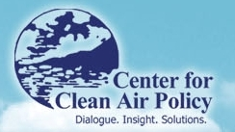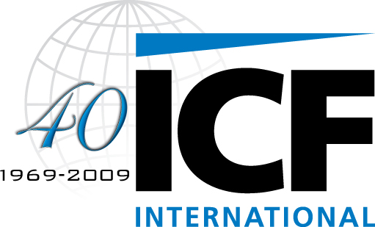

Background:
The recent concerns on climate change have originated from the observed phenomenon of global warming due to unabated greenhouse gas emission from anthropogenic sources. Intergovernmental panel on climate change, which has analyzed the phenomenon, has been directing strategies for mitigation of GHG emission and thereby reducing the uncertainties arising out of climate change.
India is on the path of economic growth, where the GDP growth is expected to be more than seven percent. The nation expects significant growth in every sector, including power, steel, cement, transport, buildings etc. Amidst the recent global economic meltdown, all this assumes even greater significance for the role that India can play and the subsequent opportunities arising out of it.
However, with the emerging development in the various sectors, comes the responsibility of tackling the issue of climate change and making efforts for GHG mitigation. The specialist from each sector feel that the mission of GHG emission mitigation is same, the strategies for addressing the mission may differ. The proposed workshop is an effort to compile viewpoints of Indian industry and government stakeholders on cost effective and pragmatic approaches to GHG emission reductions. The Integrated Research and Action for Development (IRADe), ICF International, and Center for Clean Air Policy (CCAP), have organized this workshop to understand and strategize the way forward for mitigation of GHG emission from the Indian Industry.
Objective:
The workshop aims to deliberate upon the following:
- Analysis of options for mitigation of GHG emission in the following sectors:
Electricity Demand | Electricity Supply | Cement | Iron and Steel | Transportation
- Policy implementation analysis for the above mentioned sectors.
- Implications of Domestic Policy options for international negotiations.

Organized By:

Integrated Research and Action for Development
Integrated Research and Action for Development (IRADe) is a fully autonomous advanced research institute, which aims to do research and policy analysis, impart training and serve as a hub of network among various stakeholders. The institute focuses on research for effective action through multi-disciplinary and multi-stakeholder groups for executable solutions leading to effective governance. The key focal areas are:

- Environment and Climate Change,
- Energy and Power Systems,
- Impact of Policy Reforms,
- Poverty Alleviation and Gender,
- Action Projects with Communities,
- Training and Capacity Building,

- Policy Advocacy and Dissemination.

IRADe has completed six years of successful work since its establishment. IRADe has worked with governmental, non-governmental and multi-lateral agencies such as MOEF, MNRE, MEA, Planning Commission, CSO, WISION- Germany, Stanford University- USA, SEWA, Winrock International, SANEI, UNEP-Geneva, British High Commission India, Energia International- Netherlands.

ICF International
ICF International (NASDAQ: ICFI) partners with government and commercial clients to deliver consulting services and technology solutions in the energy, climate change, environment, transportation, social programs, health, defense, and emergency management markets. The firm combines passion for its work with industry expertise and innovative analytics to produce compelling results throughout the entire program life cycle, from analysis and design through implementation and improvement.
For the last two decades, ICF has earned an international reputation in the fields of energy efficiency and climate change for our analytical rigor, in-depth expertise, and technical integrity through scores of building portfolio performance analyses and greenhouse gas emission reduction related assignments. Recently, in an independent poll in the leading international publication, Environmental Finance, ICF won the coveted titles of Best Advisor in Kyoto Project (CDM/JI), Voluntary Market, EU Emission Trading and North American Mandatory Markets. Verdantix, an independent research firm, identified ICF as the leading firm globally on climate change consulting in a survey of 16 other firms (Verdantix Green Quadrant™ Climate Change Business Consulting).
ICF has undertaken energy and climate change analyses to support strategy development for several national governments, international agencies, and more than 60 of the world’s leading Fortune 500 companies measured by market capitalization. Since 1969, ICF has been serving government at all levels, major corporations, and multilateral institutions. More than 3,000 employees serve these clients worldwide and with revenues in excess of $700 million. ICF International maintains a fully staffed office in New Delhi.

Center for Clean Air Policy
Since 1985, the Center for Clean Air Policy (CCAP) has been a recognized world leader in climate and air quality policy and is the only independent, nonprofit think tank working exclusively on those issues at the local, U.S. national and international levels. Headquartered in Washington, D.C., CCAP helps policy-makers around the world develop, promote and implement innovative, market-based solutions to major climate, air quality and energy problems that balance both environmental and economic interests.
Programs of CCAP around the World
CCAP works extensively in Europe, Asia and Central and South America. The major international initiatives include:
- Future Actions Dialogue on International Actions to Address Climate Change (FAD), combining more than 30 countries worldwide for in-depth analysis and development of climate policy options for consideration in the post-2012 Kyoto Protocol negotiations;
- European Dialogue on the Climate and Energy Challenge, developing medium- to long-term climate change, energy and finance policy for the European Union in parallel with the U.S. Climate Policy Initiative;
- Developing Countries Project, leading collaboration to identify technologies and approaches to reduce GHG emissions in China, India, Brazil, and Mexico and help these countries develop a more significant role in the UN international climate change negotiations; and
- Sectoral Study, exploring actions necessary for sectoral approaches to become a key tool in the mitigation of GHG emissions and as a necessary component of a post-2012 international climate change agreement.
- REDD Project, working at the international (UNFCCC) level to develop post-2012 policy architectures to Reducing Emissions from Deforestation and Forest Degradation (REDD) in developing countries in areas such as REDD financing, permanence and leakage, and at the in-country level in Brazil, Mexico, Indonesia and Cambodia to design practical REDD strategies tailored to each country’s specific circumstances.

