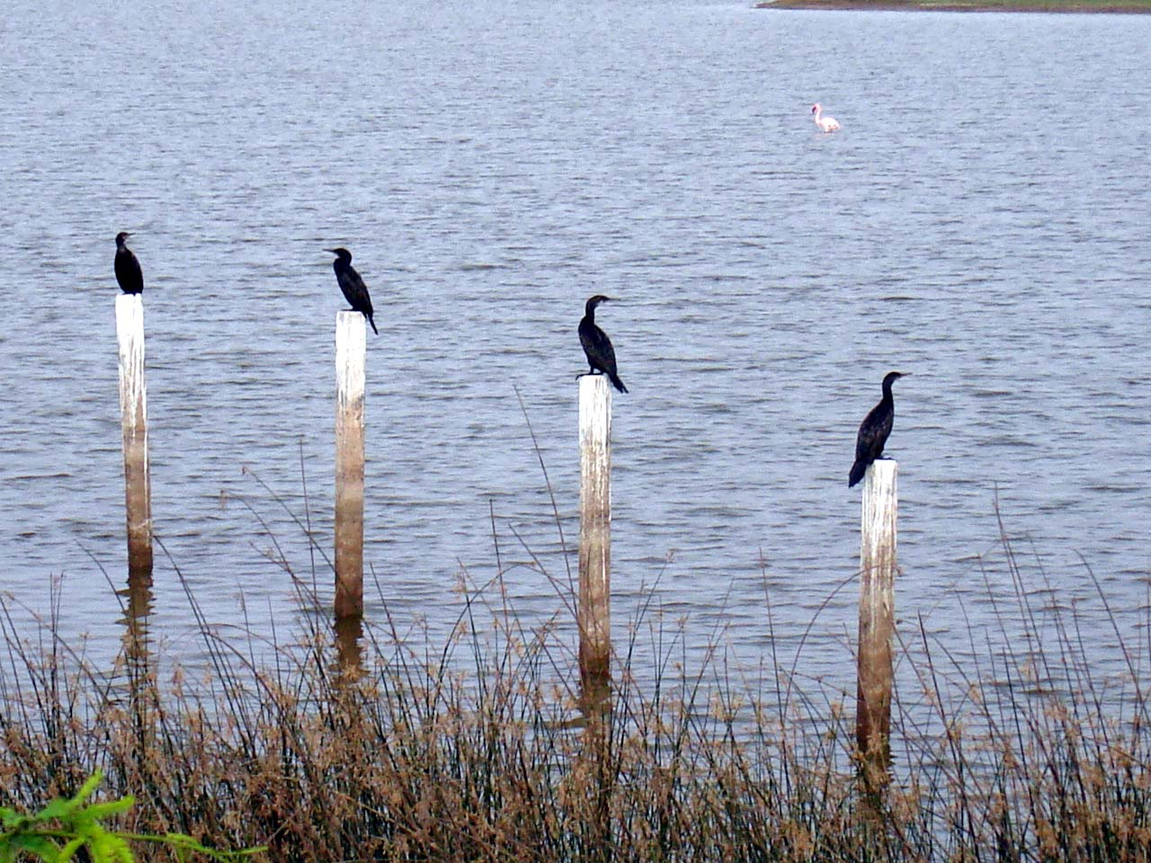

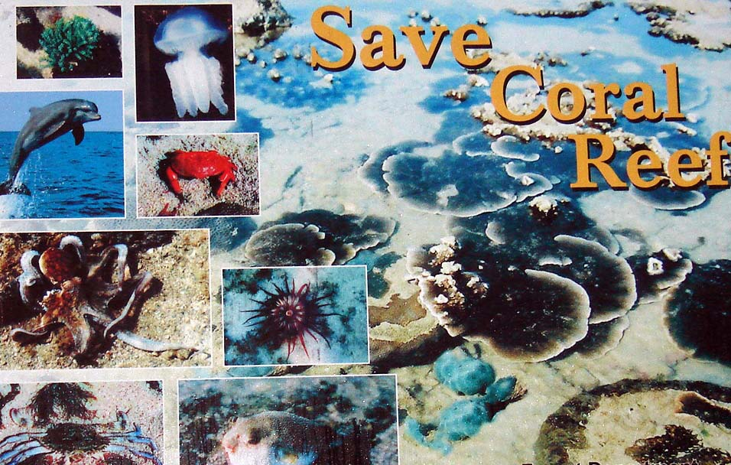

Workshop on
Review workshop on Preliminary assessment of the MNP project activities Jamnagar, Gujarat

7th November 2009, Jamnagar

Organised By

Integrated Research and Action for Development (IRADe), New Delhi

Supported By
Ministry of Environment and Forest, GOI
Forest Department of Gujarat



Introduction:

The Marine National Park in Gujarat is India’s first marine park. In 1992 the core area of this area was given of The Marine National Park under the provision of Wildlife (Protection) Act, 1972. There are 30 to 40 islands on the Jamnagar coast in the Marine National Park, in a biodiversity hotspot with the mangrove ecosystem surrounded by coral reefs.

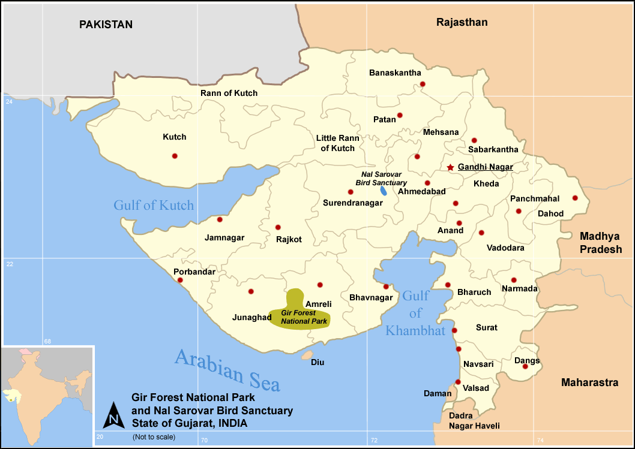

Mangroves are the tidal forests of coastal wetlands, existing in the intertidal zones of sheltered shores, estuaries, tidal creeks, back waters, lagoons, marshes and mudflats of the tropical and sub tropical regions of the world.

Workshop objectives:

After the inception workshop of IRADe on 3rd March 2009 at Gandhinagar, where the main issues of discussion were , partnerships from all concerned sectors in the preservation of Marine National Park and sharing the studies and works that had come up on the subject and ways to go ahead further in minimizing impacts on the marine ecosystem. The second workshop in this line is aimed at binding the task force’s objectives of collaborative action in the management of MNP. Broadly the following:
- to review and revise preliminary assessment results with the stakeholders
- Provide the basis of developing a more coherent programme in the MNP based on the assessment results.
- Disseminate information related to the conservation of the Marine National Park, the mangroves and the coral reefs.

- Discuss the responsibilities of the steering committee set up for better coordination in management efforts and to identify the strength of each department for the conservation of the MNP.

- To develop a consensus for issues like ecotourism in MNP and the nearby Khijedia Bird Sanctuary.

Important issues of discussion.
Industrialization:
Jamnagar being an industrial town, the major polluting sources in the ocean here includes effluent from chemical industries and a thermal power plant. The dumping of fly ash slurry into the bay by the thermal power stations has resulted not only in filling up of an extensive portion of the bay, but also fly ash entering the sea directly. The ash, on being carried far into the sea has caused irreversible and extensive damage to the sedimentary biota, algal beds, chunk, corals, pearl oysters and to all the biota connected with the reefs. Mangroves, which grow on the margin of the shoreline, have come to accommodate alarmingly high levels of ash borne contamination.
Today, the entire coastline is threatened by a combination of mangrove destruction, oil spills, toxic waste and reclamation. Industrial and other developments along the Gulf have accelerated in recent years with the establishment of oil refineries which can cause great damage to the mangroves and the corals
Ports and shipping:
The issues of coastal ecology covering environment its residents and visiting migrant biota has within its ambit the coastal sea its islands and the coastal lands (intertidal and coast influenced). They need to be addressed in totality, for multiple users of this resource - be it ports, shipping or mining, fishing, or tourism.
Ecotourism:
Conservation and sustainable use of nature without leaving behind traces of our presence. That what Eco- tourism is meant to be. In the face of a burgeoning population and unimpeded industrialization of our planet, discovering the untouched pristine wilderness is no better than a dream. India offers myriad exciting experiences to tourists. Tourism industry in India is being utilized as a powerful tool to facilitate international understanding and enable building of broader cultural horizons. According to the Travel & Tourism Competitiveness Report 2009 brought out by World Economic Forum, India is ranked 11th in the Asia-Pacific region and 62nd overall in a list of 133 assessed countries in 2008, up three places since 2007. In terms of travel, India stands 9th in the index of relative cost of access (ticket taxes and airport charges) to international air transport services, having almost the lowest costs in the world.

ABOUT INTEGRATED RESEARCH AND ACTION FOR DEVELOPMENT (IRADe)

A ‘think tank’ that works with ‘action tanks’. Integrated Research and Action for Development (IRADe) is a fully autonomous advanced scientific and research institute, which aims at research and policy analysis, impart training and serve as a hub of network among various stakeholders. The institute focuses on research for effective action through multi-disciplinary and multi-stakeholder groups for executable solutions leading to effective governance. The key focal areas are

- Environment and Climate Change,
- Energy and Power Systems,
- Impact of Policy Reforms,
- Poverty Alleviation and Gender,
- Action Projects with Communities,
- Training and Capacity Building,
- Policy Advocacy and Dissemination.
- Urban development and Climate adaptation (Centre of Excellence)

In a short span of time, IRADe has started working with government, non-government and multi-lateral agencies such as MOEF, MNRE, MEA, Planning Commission, CSO, WISION- Germany, Stanford University- USA, SEWA, Winrock International, SANEI, UNEP-Geneva, British High Commission India, Energia International- Netherlands, IIASA, as well as with private sector and Reliance Industries Limited. IRADe has completed seven years of successful work since its establishment.

Dr. Jyoti Parikh
Executive Director, IRADe
C-50, Asian Games Village Complex
Khelgaon, New Delhi-110049

Telephone: +91-11-26495522/26490126
Tele-fax: +91-11 26495522
Email: jparikh@irade.org
www.irade.org

For more information, Plz contact:
Ms Monica JP (09999591716)
Mr. Anand Patel (09990309059)
Ms. Reneema Hazarika(09968589566)

