Workshop Brochure

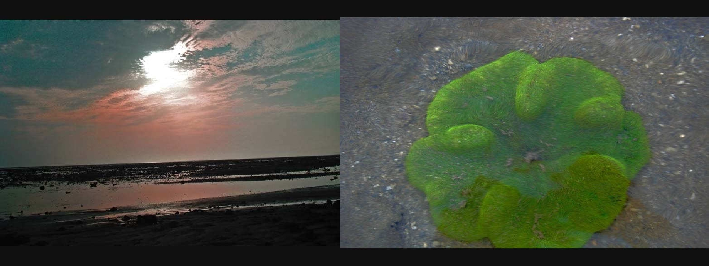
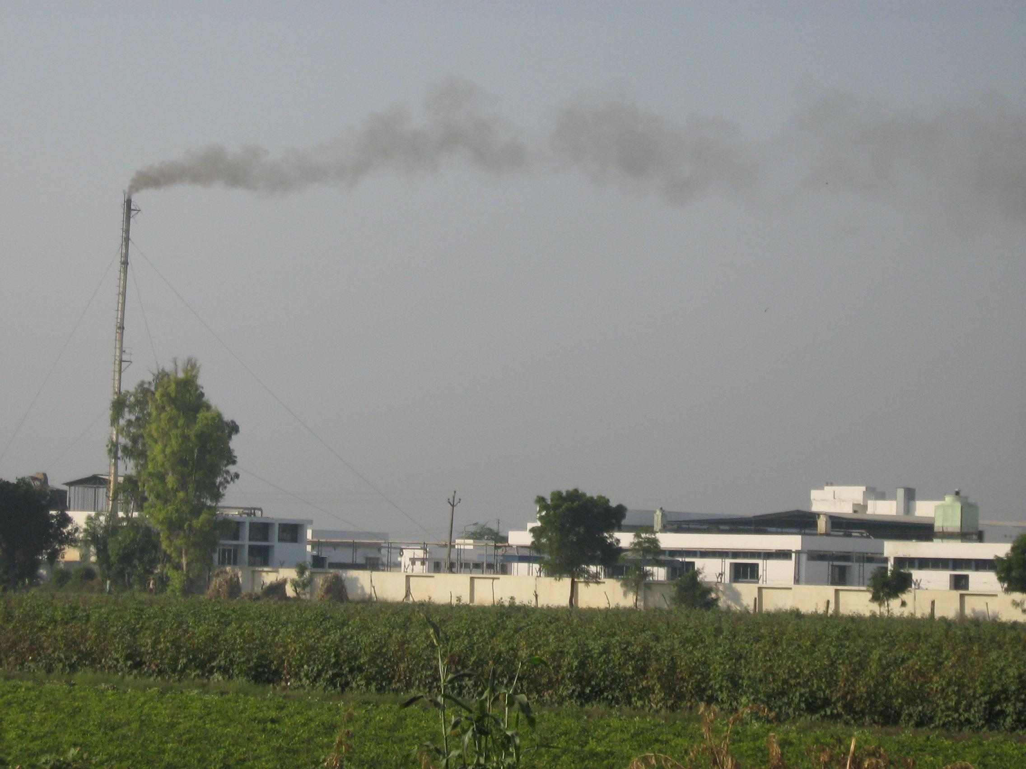

Final Workshop on
“Consultation / Review of Recommendations on Industrial Development and Conservation of Marine National Park”, Jamnagar, Gujarat

Gandhinagar, Gujarat

Organised By

Integrated Research and Action for Development (IRADe), New Delhi

Supported By
Ministry of Environment and Forests, GOI

In association with
Gujarat Forests Department

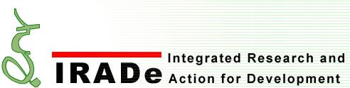

INTRODUCTION
The coastal belts of India are the hub of economic growth and technical progress, Jamnagar District is one of the busiest among them. Moreover it is the fortunate to have a district with triple blessings: Mangroves, Coral reefs and Bird Sanctuary. It has the Marine National Park and Sanctuary (MNP&S), a reservoir of ecological wealth and yet hosts a number of industries particularly between Vadinar and Sikka. Inundated by temperamental seawaters twice a day, the Marine National Park is a very fragile eco-system, which supports an amazing marine life and biodiversity. But the real challenge is how to have the industrialization that is in harmony with natural ecosystem. It is possible only by joining hands and discussing it from a common platform. This is a crucial time to ensure the marine ecosystem which is the treasure of ecological assets of the country be part of the framework in the protection, conservation and most important the development of the coastal areas. This requires combined efforts of all the concerned parties i.e. the government, big and especially small industries, municipality, NGOs, local communities etc. The existing long-term ecosystem research and monitoring programs by reputed institutions in Gujarat and elsewhere form an excellent working baseline to start from.

Integrated Research for Action and Development (IRADe), in New Delhi (www.irade.org) is currently undertaking a project on the Ecosystem Management of the Marine National Park, Jamnagar by the Ministry of Environment and Forests, Government of India. Through multi-stakeholders consultation, are collectively addressed long-term ecological and environmental concerns of this biodiversity-rich area. Keeping in view the rapid industrialization and other developments in the area, the concerned parties are required to have their development and management plan in a sustainable manner.

GOAL OF THE WORKSHOP

The final workshop, through process of dialogue and sharing the most suitable practices of Marine National Park conservation in harmony with industrial development will be identified. It will also highlight the interventions needed from different parties to ensure that those practices from holistic and multidisciplinary analysis and processes are mainstreamed. The main purpose is to finalise recommendations emerged from the study and consultation among.

OBJECTIVES

The purpose of this final workshop is to mainly discuss with all concerned parties about the steps needed for preservation of Marine National Park. It is also to discuss the works that have been done so far on the subject and how to go ahead further in minimizing adverse impacts on the marine ecosystem.

STAKEHOLDERS AND TARGET AUDIENCE

Major concerned parties are from State Departments such as Forests Department, Gujarat Industrial Development Corporation, Gujarat State Pollution Control Board, Gujarat Infrastructure Development Board, Gujarat Tourism Corporation, Department of Ports and Transportation, District Administrators, Jamnagar Municipal Corporation, etc. Other parties include ISRO (SAC), GEC, GES, GEER Foundation, and private industries such as ESSAR, RELIANCE, TATA Chemicals and other industries, Port developers and managers, urban planners, Universities, Civil Society Organizations (CSOs), NGOs, etc.

EXPECTED OUTCOMES OF THE WORKSHOP
- Stakeholder awareness on the various issues of conservation in and around the Marine National Park.
- Collection of priorities and recommendations for policy actions,
- Garnering support from the sector including industries, port and shipping and municipalities for conservation of the biodiversity of the coastal region including the flora and fauna.
- Framing implementation plans for blending the economic and control measures for conservation of Marine biodiversity.

INTEGRATED RESEARCH AND ACTION FOR DEVELOPMENT (IRADe)

A ‘think tank’ that works with ‘action tanks’. Integrated Research and Action for Development (IRADe) is a fully autonomous advanced scientific and research institute, which aims at research and policy analysis, impart training and serve as a hub of network among various stakeholders. It works with The institute focuses on research for effective action through multi-disciplinary and multi-stakeholder groups for executable solutions leading to effective governance. The key focal areas are

- Environment and Climate Change,
- Energy and Power Systems,
- Urban Infrastructure and Services,
- Poverty Alleviation and Gender,
- Policy Analysis and Reforms,
- Action Research, Training, Monitoring & Evaluation.

In a short span of time, IRADe has started working with government, non-government and multi-lateral agencies such as MOEF, MNRE, MEA, Planning Commission, CSO, WISION- Germany, Stanford University- USA, SEWA, Winrock International, SANEI, UNEP-Geneva, British High Commission India, Energia International- Netherland, and PETROFED as well as with private sector and Reliance Industries Limited.

Dr. Jyoti Parikh
Executive Director, IRADe
C-50, Asian Games Village Complex
Khelgaon, New Delhi-110049

Telephone: +91-11-26495522/26490126
Tele-fax: +91-11 26495522
Email: jparikh@irade.org
www.irade.org

For more information, Pl contact:
- Md Fahimuddin (Mob: 09654536018, Email: mdfahim@irade.org)
- Ms Moumita Paul (Mob: 09560963154, Email: mpaul@irade.org)

