IRADe-SEWA Pilot Project
For

Establishing the
Solar Assembly Centre
at
Degam Village (Gujarat), India

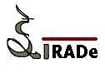



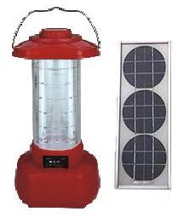



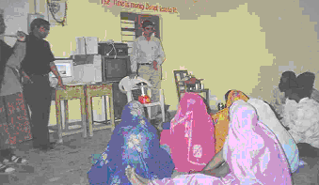

Introduction

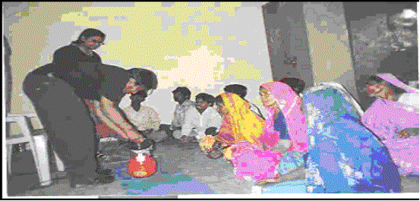
Self Employed Women’s Association (SEWA), Ahmedabad has been implementing a large programme for improving the living conditions and livelihoods of earthquake affected people in three districts of Gujarat – Surendranagar, Patan and Kutch. A total of 400 villages in these three districts are to be covered under various activities. To incorporate energy technology systems, specially the solar energy in the programme, SEWA is working in collaboration with Integrated Research and Action for Development (IRADe), New Delhi. The aim of the project is to facilitate the livelihood options of the people and also to improve their living conditions. Specific objectives are as listed below:
a. Increasing livelihood options for villagers
b. Enhancing the income of entrepreneurs
c. Improving the living conditions of the people in these areas

Background

Solar Assembly centre for the Degam village is proposed to be established during the pilot project to provide livelihood options to the Degam village. The project aims to train the local villagers to assemble and carry out repairs of the solar technology systems. This would be cost effective than sourcing lanterns from manufacturers and provide several employment opportunities. Besides providing alternate and additional source of lighting in the region, the solar lanterns are in much demand in the district and nearby areas. The entire programme could be linked to the SEWA Haat (village market) through the formation of marketing Self Help Groups. The project envisages the skill development of the local community, technology access and gender empowerment.

Project activities completed (December 2005)

- Awareness campaign:
IRADe Team conducted one Awareness programme for two days. Documentary films were shown to familiarize use of solar energy. A workshop was conducted to highlight the advantages of solar energy. The proposal for starting the Solar Assembly Centre was put forward in the Gram Shabha. Capacity building exercises like demonstration, preliminary exposure were done to mobilize the village community towards training for Solar Assembly Centre.

- Other Activities completed:
  - Selection of 10 trainees (3 women, 7 men) for the first phase of pilot project has already been done after screening test.
  - Two training workshops of six hours for four and three days respectively were conducted as a part of training for first phase.
  - The trainees have been given trained though training sessions on basic theory of Electricity, Solar Energy, Solar Lantern, Skill development to handle tools and electrical instruments for 42 hours including soldering of components.

Proposed future activities

Having done the training, the Solar Assembly Centre (SAC) needs to be set up. The first 10 trainees would start the assembly at this centre depending on the initial demand of the lantern. Linkages would be established with the suppliers /vendors of parts and components of the solar lantern. The lantern would be marketed under the RUDI (SEWA –IRADe emblem) of the SEWAHAAT. The Sewa Mandal would manage the sales of the lantern by using the SEWAHAAT marketing channel with IRADe’s know how in marketing models. Funds are being sought. Sponsors are welcome for initial set-up costs to ensure the solar assembly centre will be a self-sustaining unit. IRADe-SEWA plans to replicate this model to several other villages nearly 400 in the three districts of Gujarat to start with.

About Project Partners

Integrated Research for Action Development (IRADe):
IRADe is a fully autonomous advanced research institute, which aims to do research and policy analysis, train people and be a hub network among various stakeholders. IRADe is currently working with Government organizations such as the Ministry of Environment & Forest and the Ministry of Non-conventional Energy Sources. Further, IRADe has collaborated with academic and research institutions such as Stanford University, Indira Gandhi Institute of Development Research (IGIDR) and IGES Japan (Institute for Global Environmental Strategies), with multilateral organizations such as UNCTAD, UNDP, UNEP and the World Bank, and with NGOs such as ENERGIA and Winrock International India (WII). IRADe is working with Reliance Industries Limited (RIL) on CDM for Coal Bed Methane utilization project.

Self-Employed Women’s Association, (SEWA) Ahmedabad:
SEWA registered trade union under the Indian Trade Unions Act of 1926. It is an organisation of poor, self-employed women workers. These are women who earn a living through their own labour or small businesses.

Contact Us:
Jyoti Parikh,
Executive Director
Integrated Research and Action for Development (IRADe)
C-50, Chhota Singh Block
New Delhi 110049 Tel: 91-11-26495522-23 Fax: 91-11-26495522 – 23
E-mail: jparikh@irade.org
Website: http://www.irade.org

