Ritu Ke Rang

Cultural feast of rare ragas by
“Ustad Aslam Hussain Khan”
Accompanied by Vajahat Hussain Khan

on the occasion of the Birth Centenary of
“Gayan Samrat Ustad Azmat Hussain Khan”

India International Centre, New Delhi
6:00 P.M, September 5th, 2012
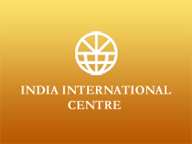
Ustad Aslam Hussain Khan
Aslam Khan is a child prodigy. Initially trained in Music by his maternal uncle Haji Ustad Altaf Hussain Khan of Khurja Gharana. Later in Mumbai in 1950. His brother in law Gayan Samrat Ustad Azmat Hussain Khan “dilrang” of Atruli(Jaipur) Gharana for 20 years. He also learnt from the famous Ustad Vilayat Hussain Khan “Pranpiya” (Agra Gharana) and Ustad Khadim Hussain Khan.
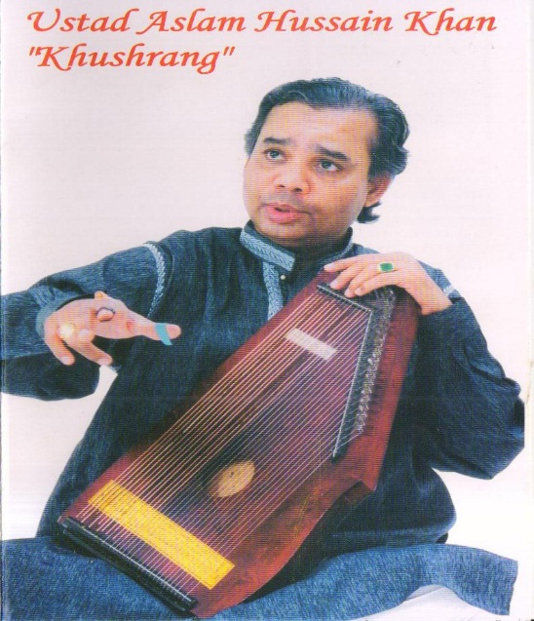
Ustad Aslam Khan is an inimitable Khayal maestro. His inborn genius enables him to blend the diverse speciality of each respective Gharana into an individual style which has tremendous aesthetic appeal. He also sings Thumari, Dadra, and Ghazals with the flair of a maestro. He is also an expert on history and philosophy the music & poetry of Hazarat Amir Khusro (R.A).
Ustad Aslam Khan’s music has been recorded extensively by Sangeet Natak Academy, N.C.P.A. All India Radio and Samwad Foundation. He has recorded more than 400 ragas and bandishes with ITC (SRA), Saptak (Ahmedabad) SNA (New Delhi) AIR (Delhi & Mumbai) and Goa (Kala Academy) a great achievement indeed. The HMV Co. (RPG) has recorded his rare classical Ragas. There is a documentary film “Raag Miya Malhar” superbly sung by him. In 2007 “Banyan tree “recorded the rare classical bandishes. He has given a number of concerts in India and abroad.
In recent times Aslam Khansahab has been declared as one of the greatest exponents of khayal gayaki & the senior most representative of the legendary Khurja, Atraul(Jaipur) & Agra Gharanas.
He will be accompanied by Ustad Vajahat Hussain Khan, the son of Ustad Azmat Hussain Khan also trained by father. He is an accomplished singer who has given many concerts in India and abroad.
******************************************************************

Birth Centenary Celebrations of
Gayan Samrat Ustad Azmat Hussain Khan, Dilrang (1911-1975).

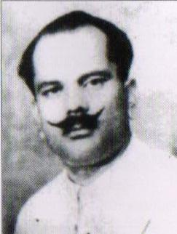
Gayan Samrat Ustad Azmat Hussain Khan Dilrang (1911 to 26th July 1975), a dedicated classical musician, composer, musicologist, teacher and poet was born in Atrauli (Dist. Aligarh U.P). Khansahab was acknowledged as one of the leading exponents of Atrauli (Jaipur), Khurja and Agra Gharanas. He had his initial training under his maternal uncle Haji Ustad Altaf Hussain Khan of Khurja Gharana and had his first performance at the age of eleven. He migrated to Maharashtra in 1930 and made Mumbai his home. Here, he had the privilege of learning classical music from his paternal uncle Ustad Allahdiya Khansahab of Atrauli (Jaipur) Gharana and brother in law, Ustad Vilayat Hussain Khan of Agra Gharana. He evolved into a much respected and fine musician who performed during the Golden age of classical music at various well known concerts and conferences with other leading musicians of his time all over India.
In 1948, Pandit Jawaharlal Nehru, the first Prime Minister of India, invited him to perform at the first anniversary of Indian Independence. Similarly, he was invited for a Darbar Concert and honoured by Maharaja Shri Sayajirao Gaikwad (Baroda) in 1935. Smt. M.S. Subalaxmi, and Pt. Shriniwas Iyer specially invited him to Chennai for a concert at Trivandrum Academy after his first National Programme (1953). The Maharaja of Nepal invited him for a concert with State honours in 1948. King Zaheer Shah of Afghanistan specially organised his concert in the celebration ceremony of the Independence of Afghanistan (1954). In the year 1973 he was felicitated with full honours by Nawab Ali Yavar Jung, the then Governor of Maharashtra. The Municipal Corporation of Brihanmumbai, paid tributes to his services to Indian Music, by renaming a road in his name, in South Mumbai ( 1985).
As "Dilrang" he has composed more than hundred classical bandishes, in different ragas and has also created new Ragas namely, Devta Bhairav, Chandrajog and Girdhar Kalyan. An inspired musician, a brilliant composer-poet and a generous teacher, we offer this concert as a homage to Azmat Hussain Khan’s memory.

